Please find below data mapping for GUIDESTAR.ORG

1. Guidestar.org – Where to retrieve data

Please see below information on where to retrieve data for Guidestar.org.

I will be using data for a specific nonprofit to illustrate where to get the data.

* Organization Name
  + The organization name is listed at the top left of the page. See screenshot below.
  + This specific nonprofit is - <https://www.guidestar.org/profile/63-1209631>

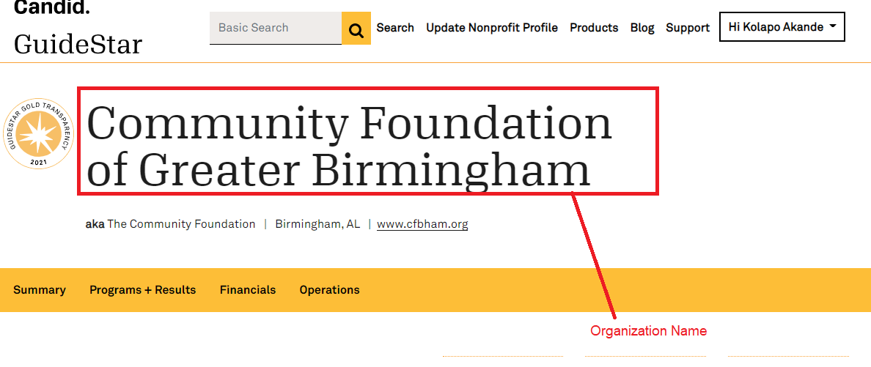

* Nonprofit Address
  + The “Nonprofit Address” is listed at the top right of the page on the right (Scroll down a little). See screenshot below.
  + This specific nonprofit is - <https://www.guidestar.org/profile/63-1209631>

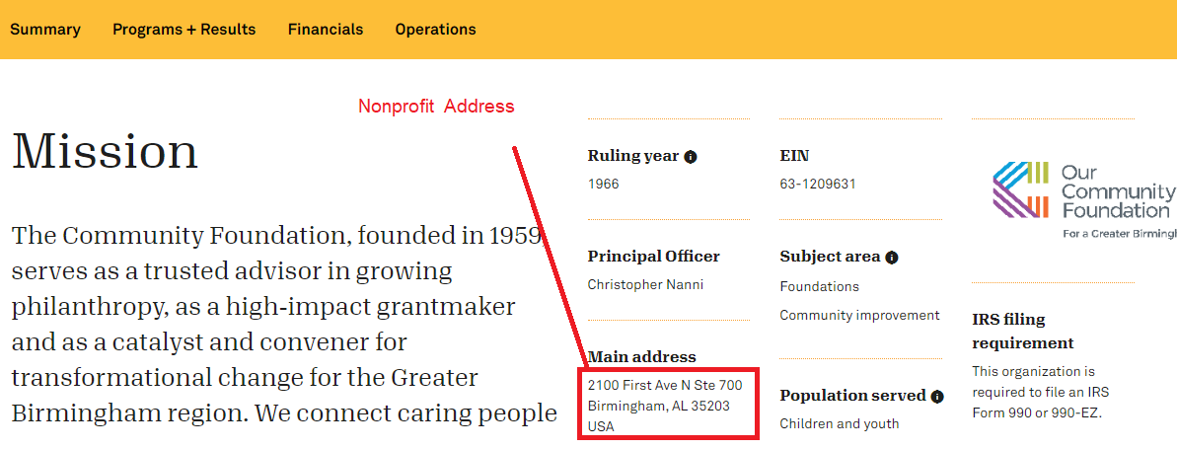

* Country
  + The “Country” is listed as part of the “Nonprofit Address” (Right after the zipcode). See screenshot below.
  + This specific nonprofit is - <https://www.guidestar.org/profile/63-1209631>
  + Note – for U.S – please save in database in full text as “UNITED STATES OF AMERICA”

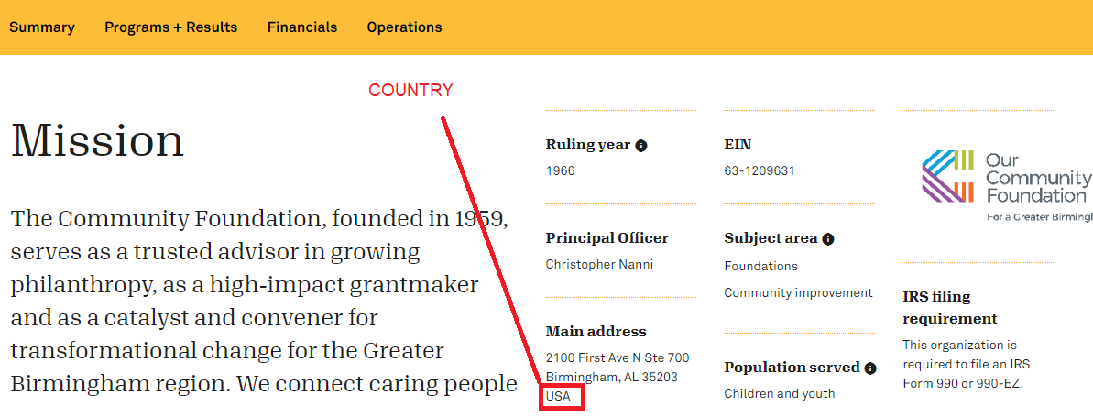

* State/Province/Territory
  + The “State/Province/Territory” is listed as part of the “Nonprofit Address”. See screenshot below.
  + It is listed right before the zipcode in the “Nonprofit Address”
  + This specific nonprofit is - <https://www.guidestar.org/profile/63-1209631>
  + Note – for States – please save in database in full text as mentioned in the “Guidestar NonProfit DataFields Needed_v1.xlsx” file , “USStates” tab
  + The state in the example below is “AL” which maps to “ALABAMA”

“ALABAMA”

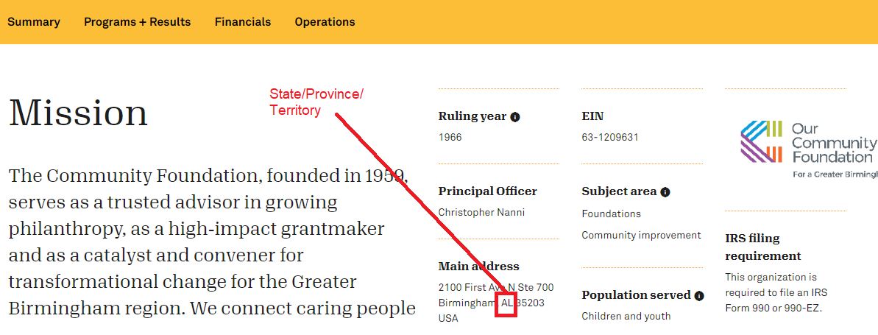

* Primary Contact (Full Name)
  + The “Primary Contact” is listed as part of the “Main Address Section”.
    - Click on the “**SHOW MORE CONTACT INFO**” under the main address, to access the screenshot below.

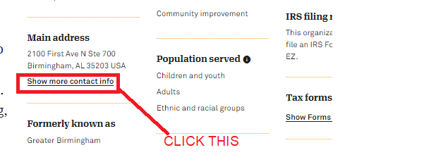

* + - Check the Contact info. It should be listed in that section.
  + This Contact full name is under the “Contact” Section - <https://www.guidestar.org/profile/63-1209631> (SEE SCREENSHOT BELOW).
  + The “Contact Full Name” in the example below is “GINGER JEFFERSON”

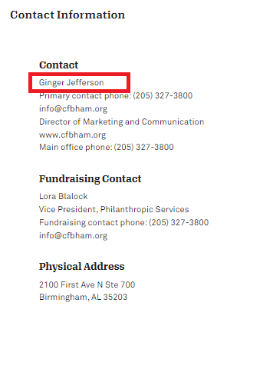

* Primary Contact (First Name)
  + The “Primary Contact” is listed as part of the “Main Address Section”.
    - Click on the “**SHOW MORE CONTACT INFO**” under the main address, to access the screenshot below.



* + - Check the Contact info. It should be listed in that section.
  + This Contact full name is under the “Contact” Section - <https://www.guidestar.org/profile/63-1209631> (SEE SCREENSHOT BELOW). It is the far left part of the full name.
  + The “Contact First Name” in the example below is “GINGER”

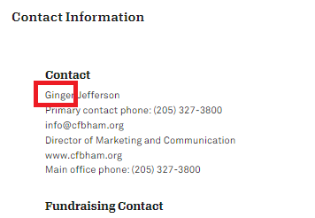

* Primary Contact (Last Name)
  + The “Primary Contact” is listed as part of the “Main Address Section”.
    - Click on the “**SHOW MORE CONTACT INFO**” under the main address, to access the screenshot below.



* + - Check the Contact info. It should be listed in that section.
  + This Contact last name is under the “Contact” Section - <https://www.guidestar.org/profile/63-1209631> (SEE SCREENSHOT BELOW). It is the far right part of the full name.
  + The “Contact Last Name” in the example below is “JEFFERSON”

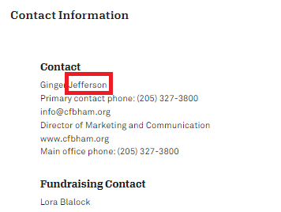

* Primary Contact (Email)
  + The “Email” is listed as part of the “Main Address Section”.
    - Click on the “**SHOW MORE CONTACT INFO**” under the main address, to access the screenshot below.



* + - Check the Contact info. It should be listed in that section.
  + This Contact “EMAIL” is under the “Contact” Section - <https://www.guidestar.org/profile/63-1209631> (SEE SCREENSHOT BELOW).
  + The “Email” in the example below is “info@cfbham.org”

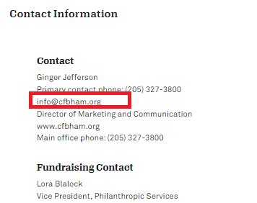

* Primary Contact (Phone)
  + The “Phone” is listed as part of the “Main Address Section”.
    - Click on the “**SHOW MORE CONTACT INFO**” under the main address, to access the screenshot below.



* + - Check the Contact info. It should be listed in that section.
  + This Contact “Phone” is under the “Contact” Section - <https://www.guidestar.org/profile/63-1209631> (SEE SCREENSHOT BELOW).
  + The “Phone” in the example below should be saved as “+1 205 327 3800”

For PHONE - prefix the country code to all phone numbers. So "205 327 3800" should be saved in the database as "+1 205 327 3800". Please take note of the format. There are no dashes in the phone number. It is ok to also leave out spaces.

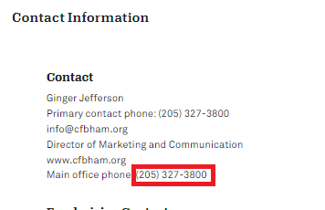

* Fundraising Contact (Full Name)
  + The “Primary Contact” is listed as part of the “Main Address Section”.
    - Click on the “**SHOW MORE CONTACT INFO**” under the main address, to access the screenshot below.



* + - Check the Fundraising Contact info. It should be listed in that section.
  + This Contact full name is under the “Fundraising Contact” Section - <https://www.guidestar.org/profile/63-1209631> (SEE SCREENSHOT BELOW).
  + The “Fundraising Contact Full Name” in the example below is “LORA BLALOCK”

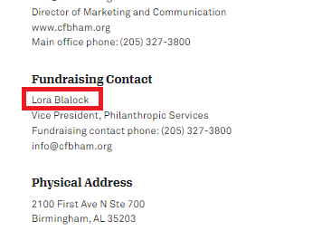

* Fundraising Contact (First Name)
  + The “Primary Contact” is listed as part of the “Main Address Section”.
    - Click on the “**SHOW MORE CONTACT INFO**” under the main address, to access the screenshot below.



* + - Check the Fundraising Contact info. It should be listed in that section.
  + This Contact first name is under the “Fundraising Contact” Section - <https://www.guidestar.org/profile/63-1209631> (SEE SCREENSHOT BELOW). It is the far left part of the full name.
  + The “Fundraising Contact First Name” in the example below is “LORA”.

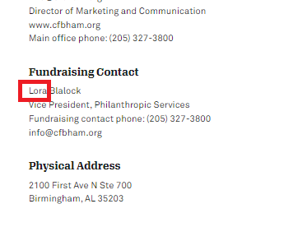

* Fundraising Contact (Last Name)
  + The “Primary Contact” is listed as part of the “Main Address Section”.
    - Click on the “**SHOW MORE CONTACT INFO**” under the main address, to access the screenshot below.



* + - Check the Fundraising Contact info. It should be listed in that section.
  + This Contact last name is under the “Fundraising Contact” Section - <https://www.guidestar.org/profile/63-1209631> (SEE SCREENSHOT BELOW). It is the far right part of the full name.
  + The “Fundraising Contact last name” in the example below is “BLALOCK”.

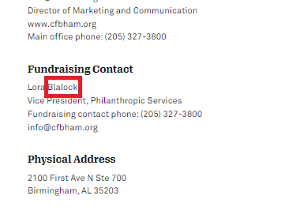

* Fundraising Contact (Email)
  + The “Email” is listed as part of the “Main Address Section”.
    - Click on the “**SHOW MORE CONTACT INFO**” under the main address, to access the screenshot below.



* + - Check the Fundraising Contact info. It should be listed in that section.
  + This Fundraising contact’s email is under the “Fundraising Contact” Section - <https://www.guidestar.org/profile/63-1209631> (SEE SCREENSHOT BELOW).
  + The “Fundraising Contact Email” in the example below is “info@cfbham.org”.

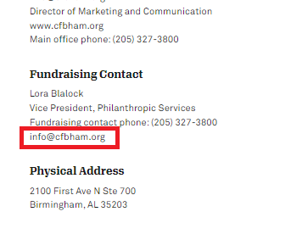

* Fundraising Contact (Phone)
  + The “Phone” is listed as part of the “Main Address Section”.
    - Click on the “**SHOW MORE CONTACT INFO**” under the main address, to access the screenshot below.



* + - Check the Fundraising Contact info. It should be listed in that section.
  + This Fundraising contact’s Phone is under the “Fundraising Contact” Section - <https://www.guidestar.org/profile/63-1209631> (SEE SCREENSHOT BELOW).
  + The “Phone” in the example below should be saved as “+1 205 327 3800”

For PHONE - prefix the country code to all phone numbers. So "205 327 3800" should be saved in the database as "+1 205 327 3800". Please take note of the format. There are no dashes in the phone number. It is ok to also leave out spaces.

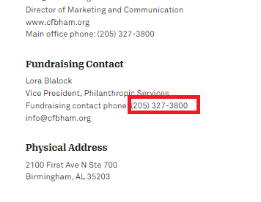

* Website
  + The “Website” is listed at the top left of the page, below the organization name. See screenshot below.
  + This specific nonprofit is - <https://www.guidestar.org/profile/63-1209631>

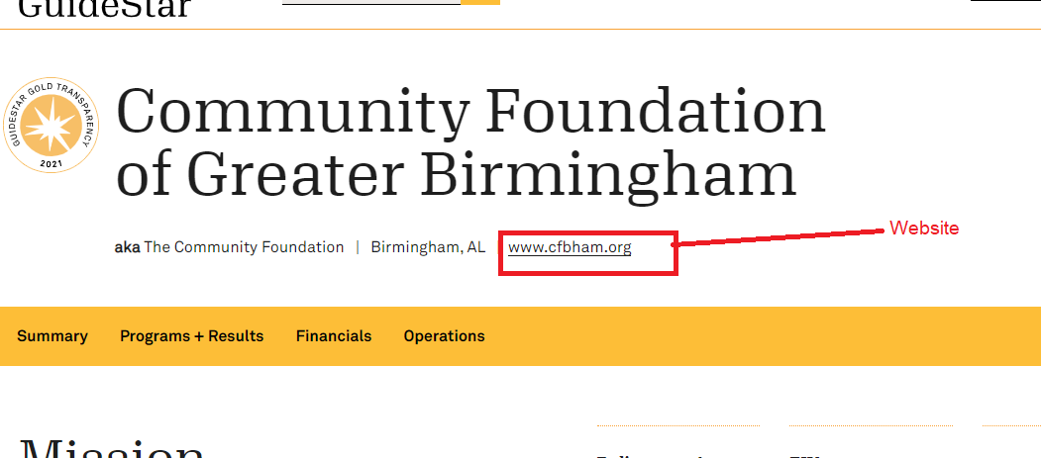

* EIN
  + The “EIN” is the “Government Registration Number” and it is listed on the right side of the page below the organization name. See screenshot below.
  + This specific nonprofit is - <https://www.guidestar.org/profile/63-1209631>
  + The EIN in the example below is “63-1209631” which maps to the saved version of

“631209631”

* + - Please remove all dashes before saving the EIN in the database

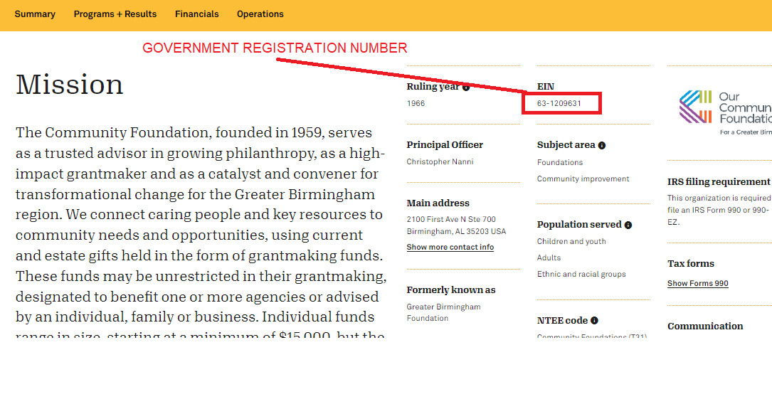

* Ruling Year
  + The “Nonprofit Registration Date (Year)” is listed below the “ruling year” text
  + This specific nonprofit is - <https://www.guidestar.org/profile/63-1209631>
  + See the screenshot below

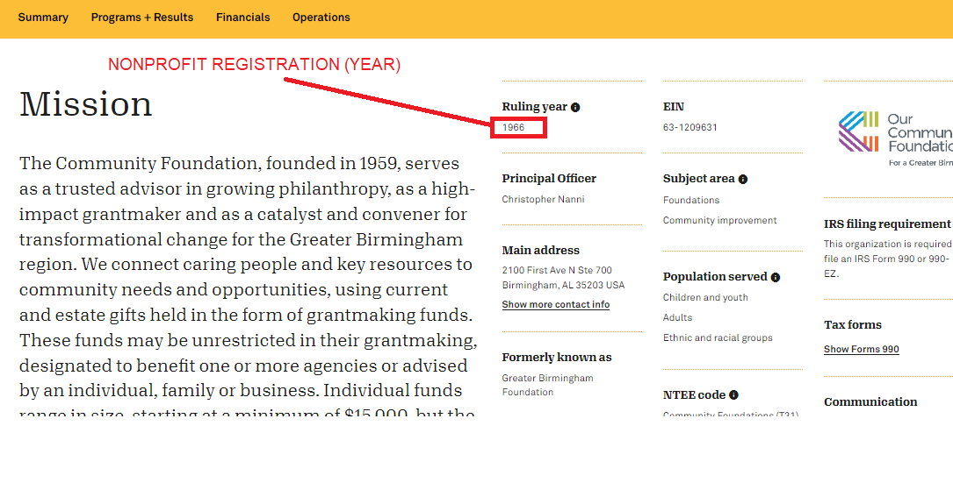

* Domain Scraped

This is the domain that is scraped. In this case for guidestar - <https://www.guidestar.org> . Please take note of formatting requirements in “Guidestar NonProfit DataFields Needed_v1.xlsx” when saving this data.

* Specific URL Scraped

These are the specific URLs that are scraped for the data collected. For Example - <https://www.guidestar.org/profile/8020647> . Please take note of formatting requirements in “Guidestar NonProfit DataFields Needed_v1.xlsx” when saving this data.